training 1 epoch...

71.02716374397278 seconds used......

1 training finished! average train loss: 0.5905534470310578

evaluating...

Confusion matrix, without normalization

[[ 18 14 13]

[ 4 134 48]

[ 1 17 336]]

Normalized confusion matrix

[[0.4 0.31111111 0.28888889]

[0.02150538 0.72043011 0.25806452]

[0.00282486 0.0480226 0.94915254]]

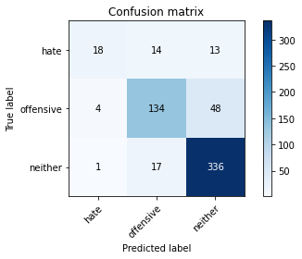

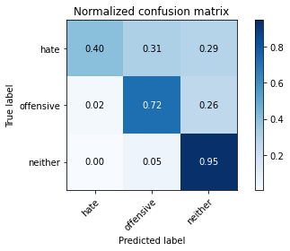

precision recall f1-score support

hate 0.78 0.40 0.53 45

offensive 0.81 0.72 0.76 186

neither 0.85 0.95 0.89 354

accuracy 0.83 585

macro avg 0.81 0.69 0.73 585

weighted avg 0.83 0.83 0.82 585

average eval_loss: 0.44381641298532487, accuracy: 0.8341880341880342

training 2 epoch...

75.9485251903534 seconds used......

2 training finished! average train loss: 0.31038767118484545

evaluating...

Confusion matrix, without normalization

[[ 8 26 11]

[ 1 158 27]

[ 0 42 312]]

Normalized confusion matrix

[[0.17777778 0.57777778 0.24444444]

[0.00537634 0.84946237 0.14516129]

[0. 0.11864407 0.88135593]]

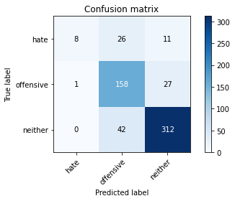

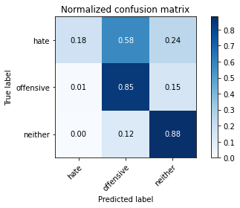

precision recall f1-score support

hate 0.89 0.18 0.30 45

offensive 0.70 0.85 0.77 186

neither 0.89 0.88 0.89 354

accuracy 0.82 585

macro avg 0.83 0.64 0.65 585

weighted avg 0.83 0.82 0.80 585

average eval_loss: 0.46602947314580284, accuracy: 0.8170940170940171

training 3 epoch...

75.81589317321777 seconds used......

3 training finished! average train loss: 0.1414830258163886

evaluating...

Confusion matrix, without normalization

[[ 28 7 10]

[ 21 132 33]

[ 13 31 310]]

Normalized confusion matrix

[[0.62222222 0.15555556 0.22222222]

[0.11290323 0.70967742 0.17741935]

[0.03672316 0.08757062 0.87570621]]

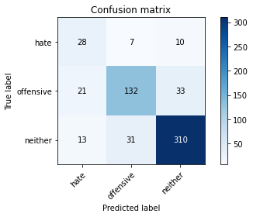

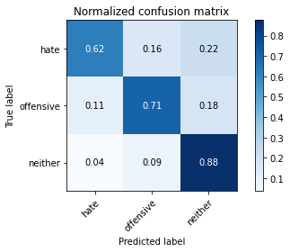

precision recall f1-score support

hate 0.45 0.62 0.52 45

offensive 0.78 0.71 0.74 186

neither 0.88 0.88 0.88 354

accuracy 0.80 585

macro avg 0.70 0.74 0.71 585

weighted avg 0.81 0.80 0.81 585

average eval_loss: 0.5932359290619691, accuracy: 0.8034188034188035

training 4 epoch...

75.75854134559631 seconds used......

4 training finished! average train loss: 0.06358414976787953

evaluating...

Confusion matrix, without normalization

[[ 20 17 8]

[ 6 159 21]

[ 6 47 301]]

Normalized confusion matrix

[[0.44444444 0.37777778 0.17777778]

[0.03225806 0.85483871 0.11290323]

[0.01694915 0.13276836 0.85028249]]

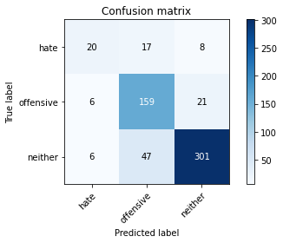

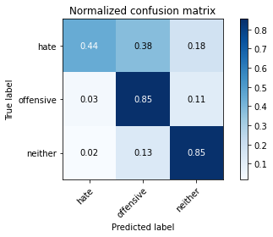

precision recall f1-score support

hate 0.62 0.44 0.52 45

offensive 0.71 0.85 0.78 186

neither 0.91 0.85 0.88 354

accuracy 0.82 585

macro avg 0.75 0.72 0.73 585

weighted avg 0.83 0.82 0.82 585

average eval_loss: 0.6404038595656554, accuracy: 0.8205128205128205

training 5 epoch...

75.73087930679321 seconds used......

5 training finished! average train loss: 0.032899664738688134

evaluating...

Confusion matrix, without normalization

[[ 24 16 5]

[ 6 156 24]

[ 7 46 301]]

Normalized confusion matrix

[[0.53333333 0.35555556 0.11111111]

[0.03225806 0.83870968 0.12903226]

[0.01977401 0.1299435 0.85028249]]

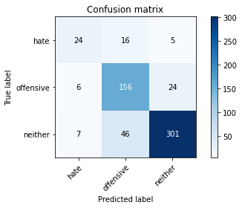

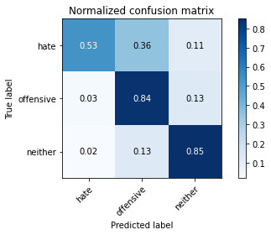

precision recall f1-score support

hate 0.65 0.53 0.59 45

offensive 0.72 0.84 0.77 186

neither 0.91 0.85 0.88 354

accuracy 0.82 585

macro avg 0.76 0.74 0.75 585

weighted avg 0.83 0.82 0.82 585

average eval_loss: 0.7686165980994701, accuracy: 0.8222222222222222

model of 3 epoch

Confusion matrix, without normalization

[[ 36 7 8]

[ 25 119 25]

[ 12 27 326]]

Normalized confusion matrix

[[0.70588235 0.1372549 0.15686275]

[0.14792899 0.70414201 0.14792899]

[0.03287671 0.0739726 0.89315068]]

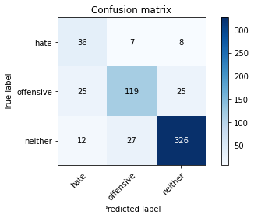

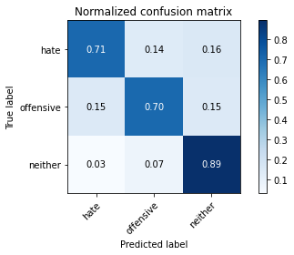

precision recall f1-score support

hate 0.49 0.71 0.58 51

offensive 0.78 0.70 0.74 169

neither 0.91 0.89 0.90 365

accuracy 0.82 585

macro avg 0.73 0.77 0.74 585

weighted avg 0.83 0.82 0.83 585

average eval_loss: 0.5590686773260435, accuracy: 0.8222222222222222

0.8222222222222222